Client / Owner: | Hamilton Wentworth Catholic District School Board
Contractor: |  | Atlantic Roofers Ontario Ltd.
Project Materials observed onsite: |  | SECUROCK Gypsum-Fiber Roof Board by CGC/USG, Dekfast System ES #12 DP Steel 1-5/8” screws w/ 3” Round Galvalume plates E-Coat Black, SOPRAFLASH STICK DUO membrane by Soprema (vapour retarder), SOPRAPLY FLAM STICK membrane by Soprema (vapour retarder flashing), ELASTOCOL STICK primer by Soprema, SOPRAMASTIC by Soprema, Tapered insulation from ACCU-PLANE

Pretium was on site to review the progression of work. Only items observed by the reviewer and reported herein have been reviewed. Other conditions may be present that were not apparent to the reviewer at the time of the visit. The following was observed / discussed:
OBSERVATIONS / COMMENTS
- General
  - Original Estimated Project Completion Date: August 16, 2024 (weather permitting)
  - Projected Completion Date: Currently on schedule
NOT IN CONTRACT
CONTRACTOR STAGING/PARKING
ACTIVE WORK AREA AT TIME OF VISIT
COMPLETE TO NEW CAP SHEET MEMBRABRANE
COMPLETE TO NEW BASE SHEET MEMBRANE
COMPLETE TO NEW VAPOUR RETARDER
KEY PLAN


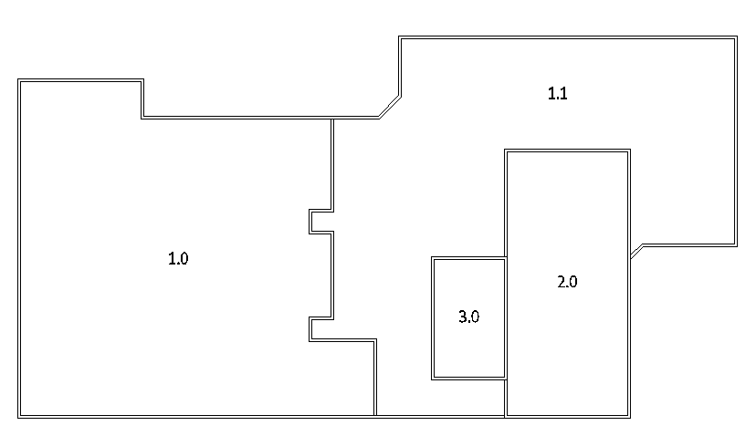
- Site / Staging Area
- Contractor to ensure site is kept clean and all debris is placed in disposal bins by the end of each day. | 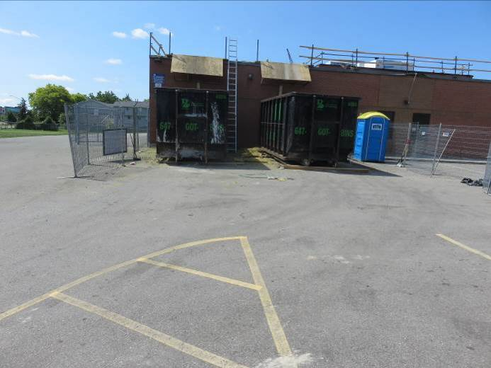
- Overhead protection is in place at the main entrance as requested by HWCDSB. | 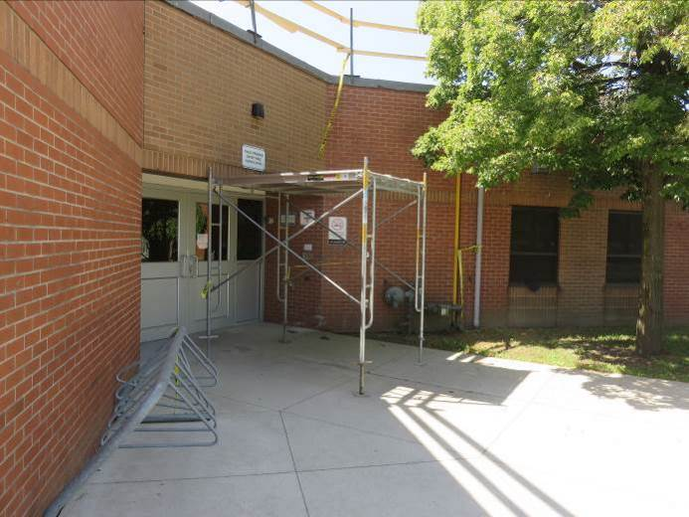

- Roof Sections 1.0 & 1.1 (Main Roof)
- Prior to Pretium’s arrival, tear off of the existing assembly and installation of the new deck overlay board was complete in the active work area (red in Key Plan). Deck overlay board was being primed prior to installation of new self-adhered vapour retarder. | 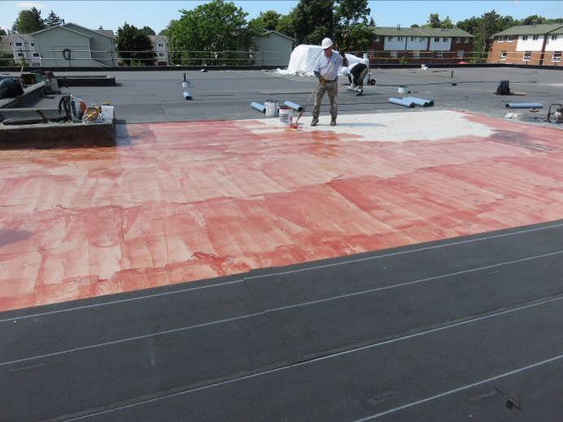
- Installation of new self-adhered vapour retarder was in progress at time of visit. | 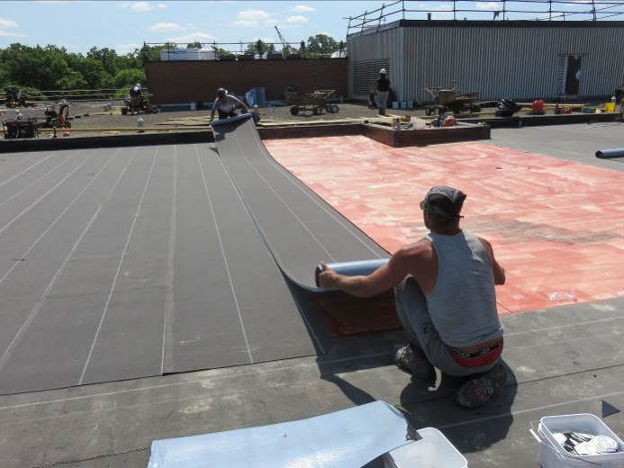
- End laps of vapour retarder were being hot air heat welded with a Leister gun. | 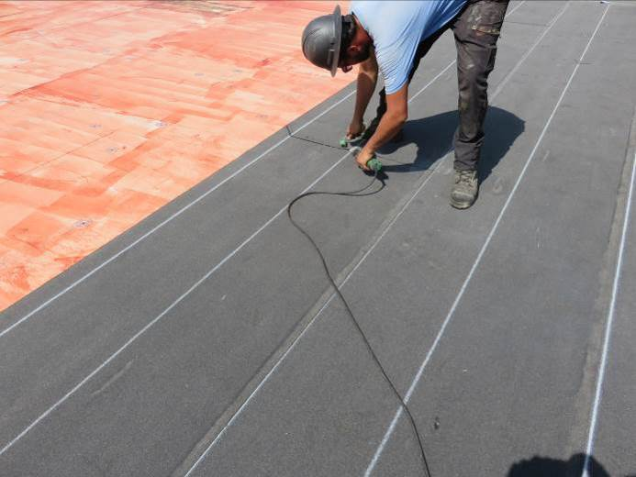
- Side laps of vapour retarder were being hot air heat welded with a robot welder. | 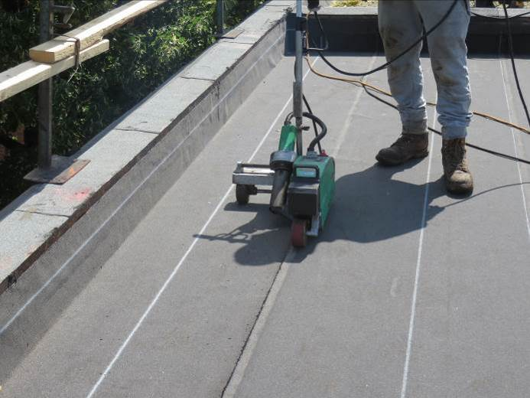
- Self-adhered vapour retarder was being rolled with a weighted roller. | 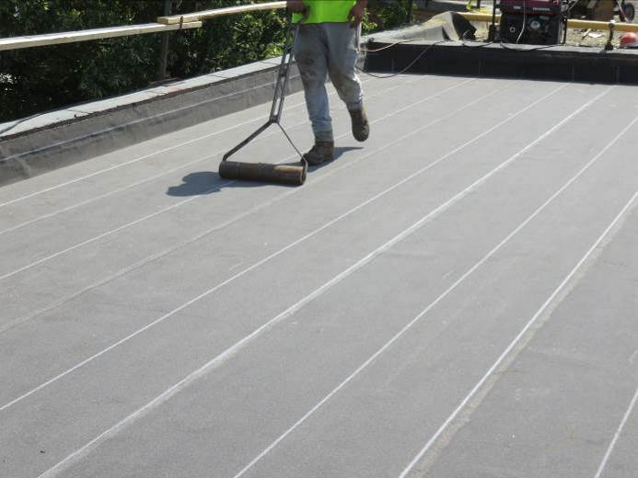
- Self-adhered vapour retarder was being turned up, hot air heat welded with a Leister gun, and rolled with a hand roller at the parapet detail. | 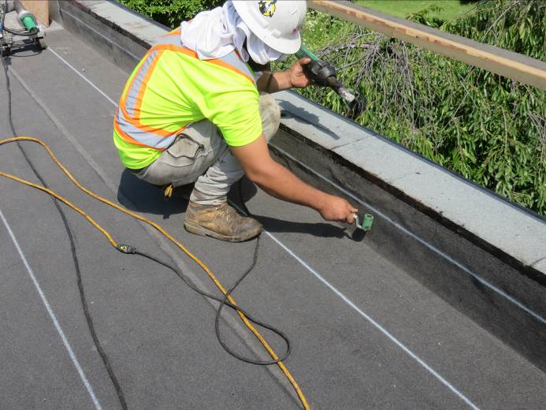
  - Foreman advised it is their intent to complete installation of new wood blocking and membrane flashing at parapet detail around section 1.0 by end of day.
- Roof Section 2.0 (Gymnasium)
- Section is complete to vapour retarder throughout field of section and new wood blocking and membrane flashing is complete at parapet. | 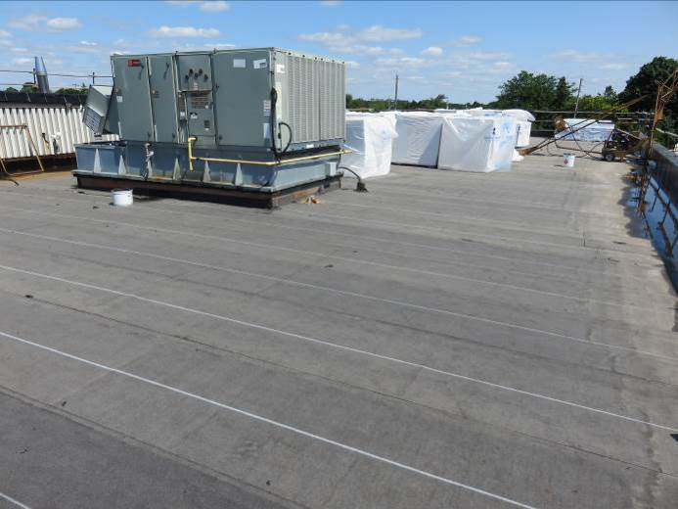
- Temporary drains have been installed at the two drains at the south end of the section. Foreman advised that the interior plumbing has been repaired at the two drains at the north end of the section. | 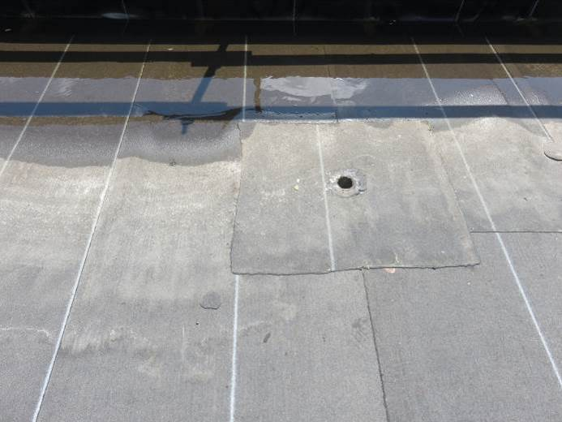
  - Foreman advised crew will be onsite Saturday (July 20) weather permitting to begin installing insulation and membrane on sections 2.0 and 3.0 (gymnasium and mechanical penthouse).

This report was issued to all parties on November 7, 2026.
Trade foreman was verbally notified of report contents. This report pertains to work specifically requested and comments only on operations and items that were visible or being undertaken at the time of our inspection.
Report by: | Dave Neal. H.Dipl.T., RRO

